Common name: Hydras
(Phylum Cnidarian: Order Hydrozoa :
Family Hydridae)

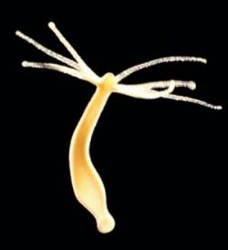
www.newscientist.com

Common name: Flatworms
(Phylum Platyhelminthes : Class Turbellaria:
Family Planariidae)

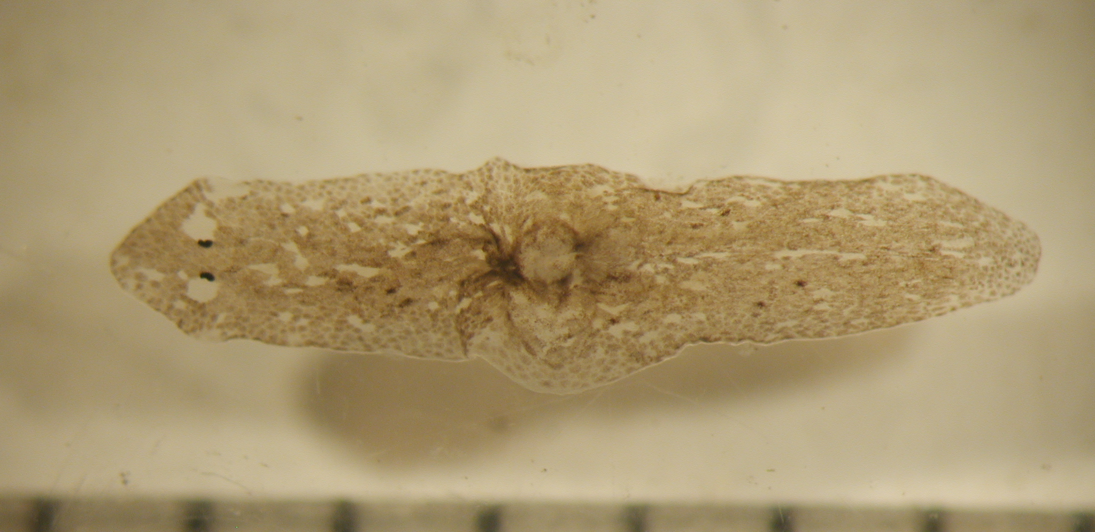
Source: http://www.vcrlter.virginia.edu/gallery

Common name: Roundworms (Phylum Nematoda)

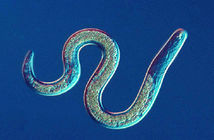
Source: http://www.canacoll.org/Nem/Main/nem.htm

Common name: Bryozoans
(Phylum Bryozoa : Class Phylactolaemata :
Family Pectinatellidae)

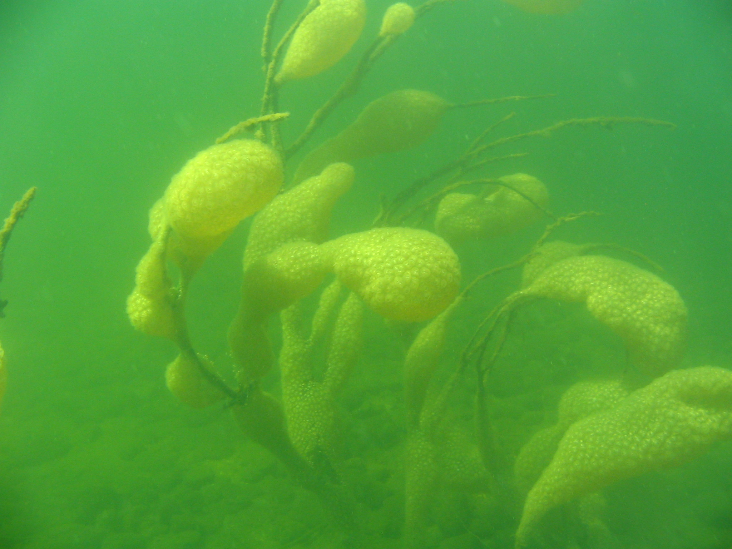
The bryozoan Pectinatella magnifica (photo by Darren Bade)

Common name: Aquatic earthworms,
often called bristle worm
(Phylum Annelida: Subclass Oligochaeta :
Family Tubificidae)

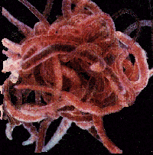
Source: http://www.inhs.uiuc.edu/~mjwetzel/

Common name: Aquatic or bristle worm
(Phylum Annelida: Subclass Oligochaeta :
Family Tubificidae)

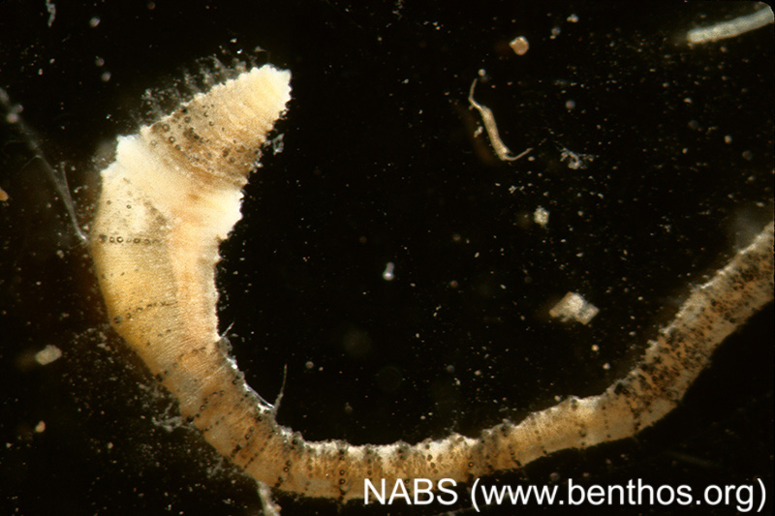
Common name: Aquatic earthworms,
often called bristle worm
(Phylum Annelida: Subclass Oligochaeta :
Family Naididae)

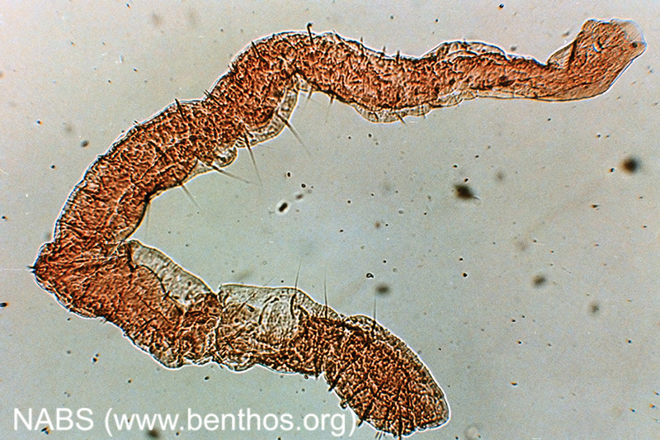

Common name: Leeches
(Phylum Annelida : Class Hirudinea :
Family Hirudinidae)

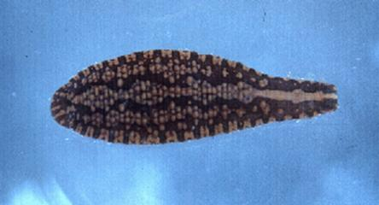
Source: http://www.biokids.umich.edu/resources

Common name: Leeches
(Phylum Annelida : Class Hirudinea :
Family Glossiphoniidae)

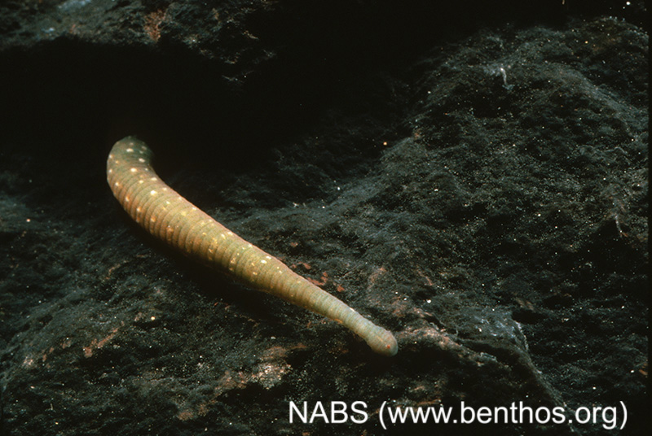

Common name: Leeches
(Phylum Annelida : Class Hirudinea :
Family Erpobdellidae)
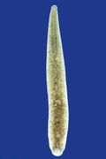
Source: http://virtual-museum.sunsite.ualberta.ca/dig
Common name: Fairy shrimps
(Phylum Arthropoda : Subphylum Crustacea:
Class Branchiopoda : Order Anostraca)

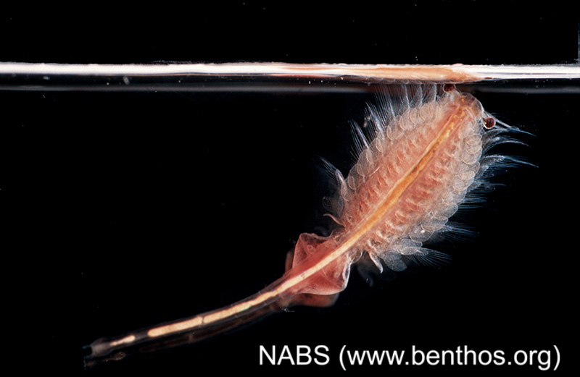

Common name: Water flea/Daphnia
(Phylum Arthropoda : Class Branchiopoda :
Order Cladocera, Family Daphniidae)

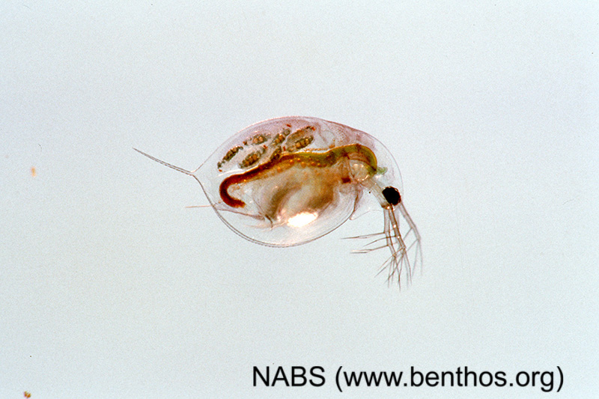

Common name: Copepods
(Phylum Arthropoda : Class Maxillopoda :
Subclass Copepoda)

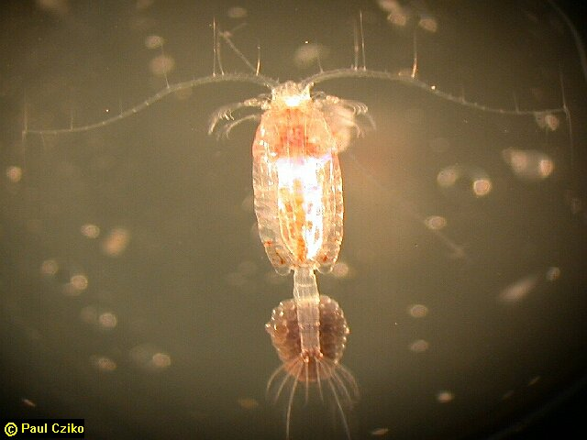

Common name: Seed shrimps
(Phylum Arthropoda : Subphylum Crustacea:
Class Ostracoda)

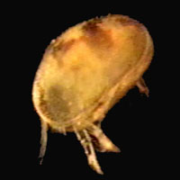
Source: http://www.eeob.iastate.edu

Common name: Sow bugs
(Phylum Arthropoda : Class Malacostraca:
Order Isopoda: Family Asellidae)

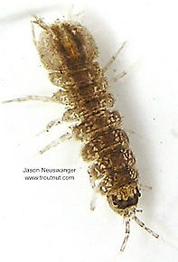

Common name: Scuds
(Phylum Arthropoda : Class Malacostraca:
Order Amphipoda: Family Gammaridae)

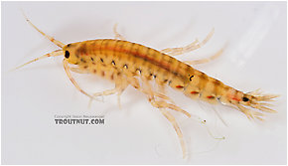
Common name: Crayfish (Phylum Arthropoda :
Class Malacostraca: Order Decapoda:
Family Cambaridae)

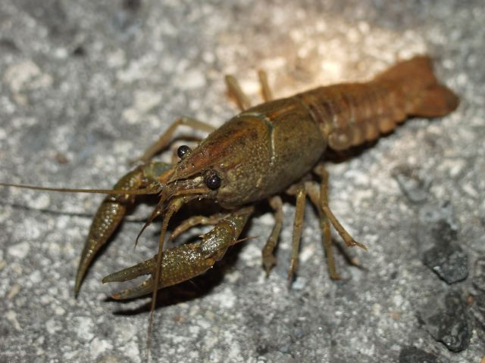
Source: http://www.biol.andrews.edu/everglades/organisms

Common name: Springtails
(Phylum Arthropoda : Class Insecta:
Order Collembola)

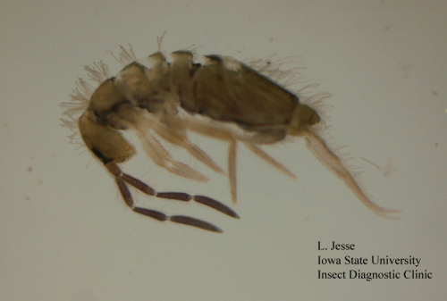

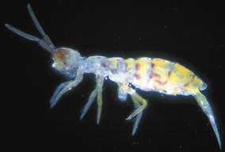
Source: http://www.eastendtalking.org.uk/safari

Common name: Mayfly (Phylum Arthropoda :
Class Insecta: Order Ephemeroptera)

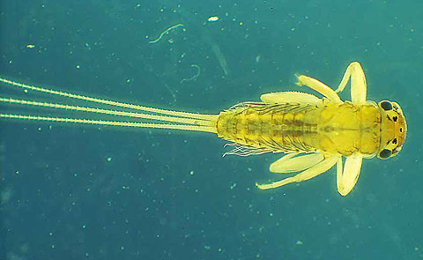
www.bugsurvey.nsw.gov.au

Common name: Dragonfly larva
(Phylum Arthropoda : Class Insecta:
Order Odonata: Suborder Anisoptera)

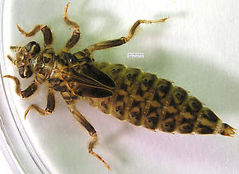

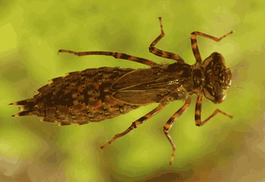
Source: http://www.btinternet.com/~andyharmer/dragonflylarvae.htm

Common name: Damselfly
(Phylum Arthropoda: Class Insecta:
Order Odonata: Suborder Zygoptera)

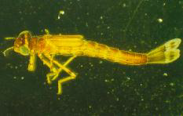
Source: http://www.tased.edu.au/tasonline/dorsetww/macroinv.htm

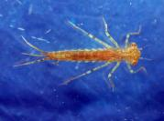
Source: http://www.landcare.org.nz/SHMAK/manual/9streamlife.html

Common name: Giant Water Bug
( Phylum Arthropoda: Class Insecta :
Order Hemiptera : Family Belostomatidae)

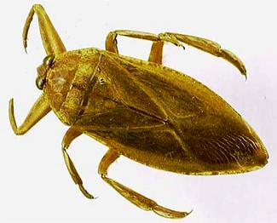
Source: http://collections.ic.gc.ca/biodiversity

Common name: water boatman
(Phylum Arthropoda: Class Insecta :
Order Hemiptera : Family Corixidae)

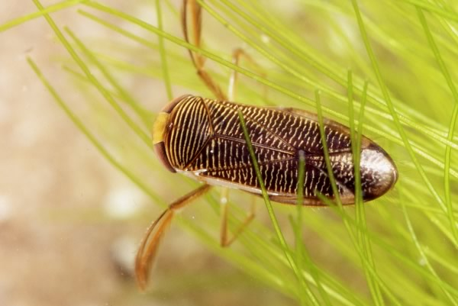
Source: http://www.koleopterologie.de

Common name: Water strider
(Phylum Arthropoda: Class Insecta :
Order Hemiptera : Family Gerridae)

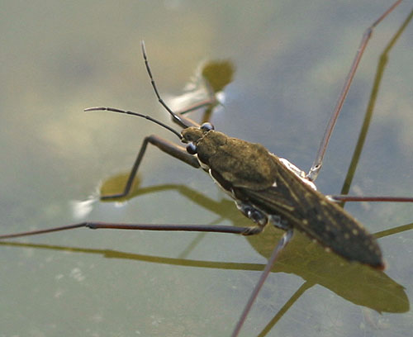
Source: http://www.myrmecos.net/insects/Gerrid1.html

Common name: Water scorpion
(Phylum Arthropoda: Class Insecta :
Order Hemiptera : Family Nepidae)

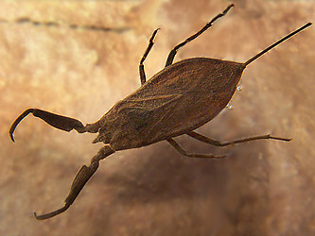
Source: http://tolweb.org/Nepidae/10925

Common name: Backswimmer
(Phylum Arthropoda: Class Insecta :
Order Hemiptera : Family Notonectidae)

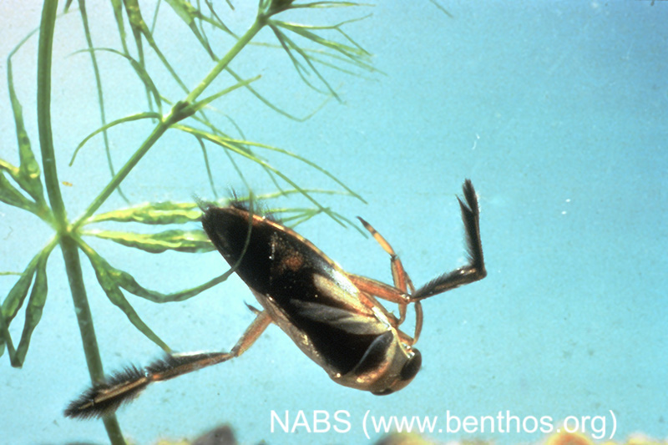

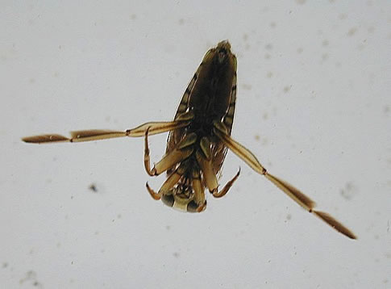
Source: http://www.cals.ncsu.edu/course

Common name: Ripple bug
(Phylum Arthropoda: Class Insecta :
Order Hemiptera : Family Veliidae)

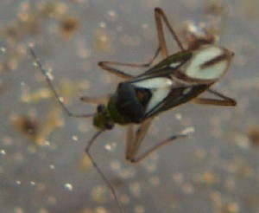
Source: http://www.umd.umich.edu/dept/na/aquatic_insecta

Caddisflies (Insecta: Trichoptera)

Common name: Caddisfly larvae
(Phylum Arthropoda : Class Insecta :
Order Trichoptera)

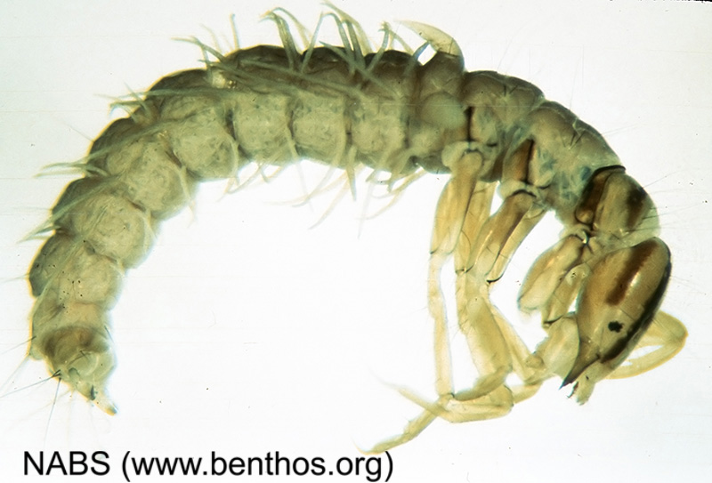

Caddisfly in case
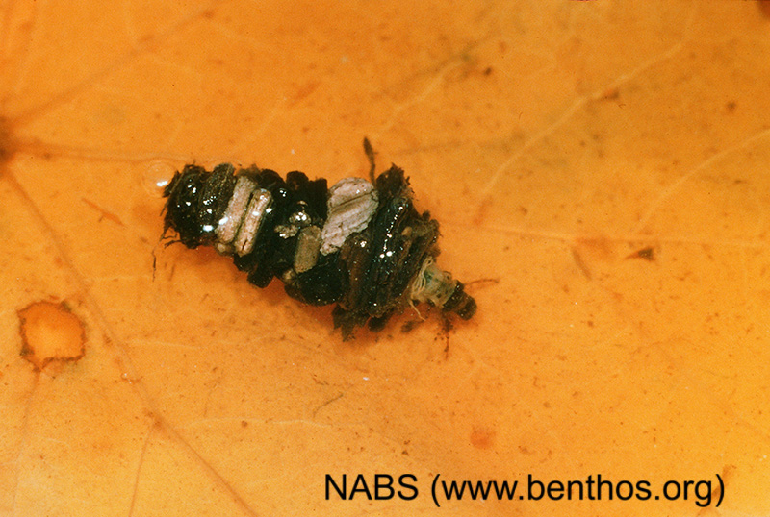

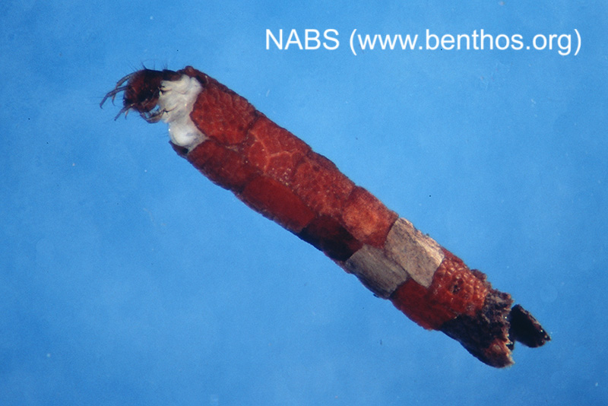

Common name: Water penny
( Phylum Arthropoda: Class Insecta :
Order Coleoptera: Family Psephenidae)

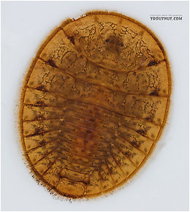

Common name: Predaceous diving beetle
(Phylum Arthropoda: Class Insecta :
Order Coleoptera : Family Dytiscidae)

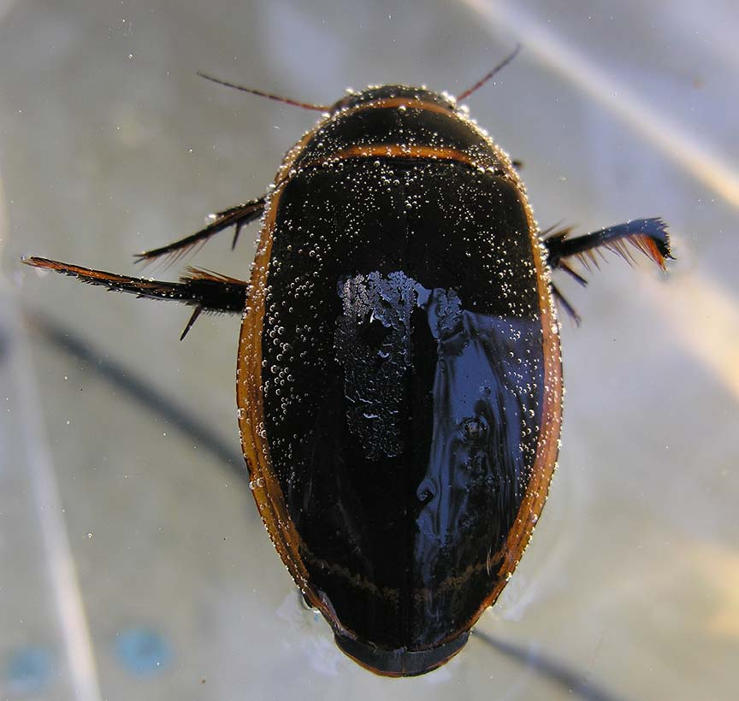
http://magickcanoe.com/insects
Common name: Crawling water beetle
(Phylum Arthropoda: Class Insecta :
Order Coleoptera : Family Haliplidae)

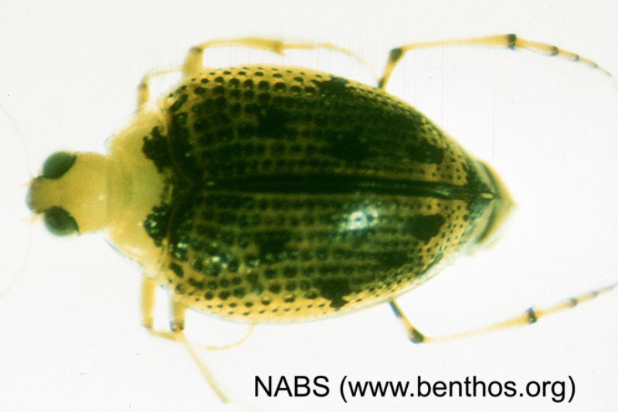

Common name: Dobsonfly larva
(Phylum Arthropoda : Class Insecta:
Order Megaloptera: Family Corydalidae)
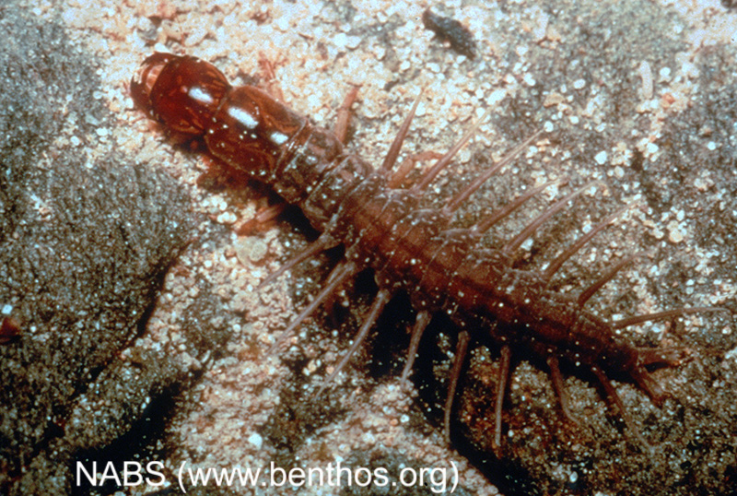

Common name: Alderfly larva
(Phylum Arthropoda : Class Insecta:
Order Megaloptera: Family Sialidae)

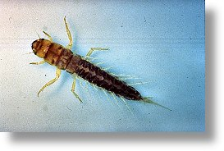

Source: http://www.benthos.org/AboutNABS/Whatisbenthos.htm

Common name: Midge (Phylum Arthropoda:
Order Diptera : Class Insecta :
Family Chironomidae)

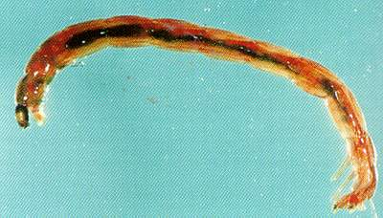
Source: http://www.dlwc.nsw.gov.au/care/wetlands/facts/

Common name: Water mites
(Phylum Arthropoda: Class Arachnid:
Family Hydracarina)

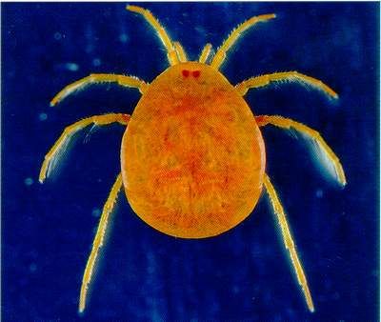

www.dlwc.nsw.gov.au/.../water_mite_eylais.jpg

Common Name: Pouch Snail
(Phylum Mollusca: Class Gastropoda:
Family Physidae)

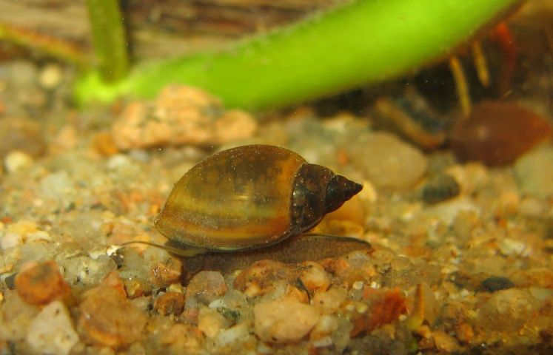
Source: http://guillaume.doucet.free.fr

Common name: Orb snail (Phylum Mollusca:
Class Gastropoda: Family Planorbidae)

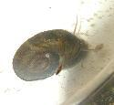

Common name: Freshwater mussel
(Phylum Mollusca: Class Bivalvia :
Family Unionidae)

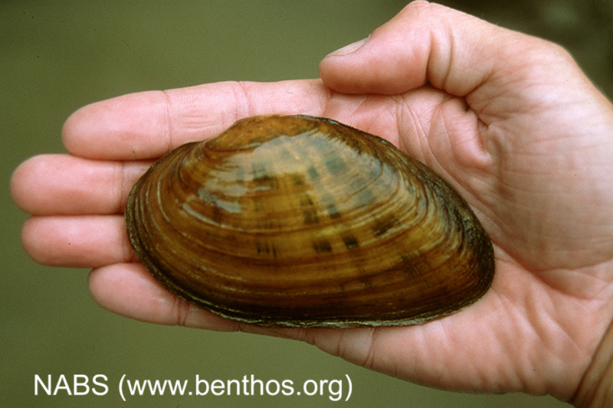

Common name: Pea clam/Fingernail clam
(Phylum Mollusca: Class Bivalvia :
Family Sphaeriidae)

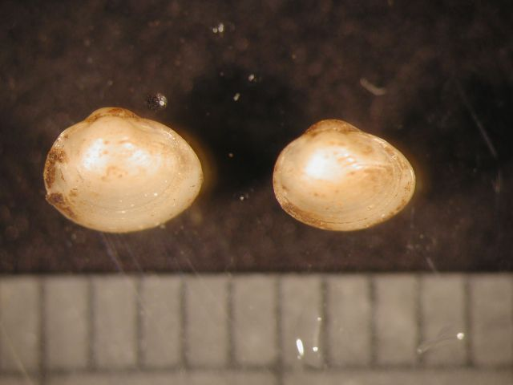
Source: http://www.vcrlter.virginia.edu/gallery

